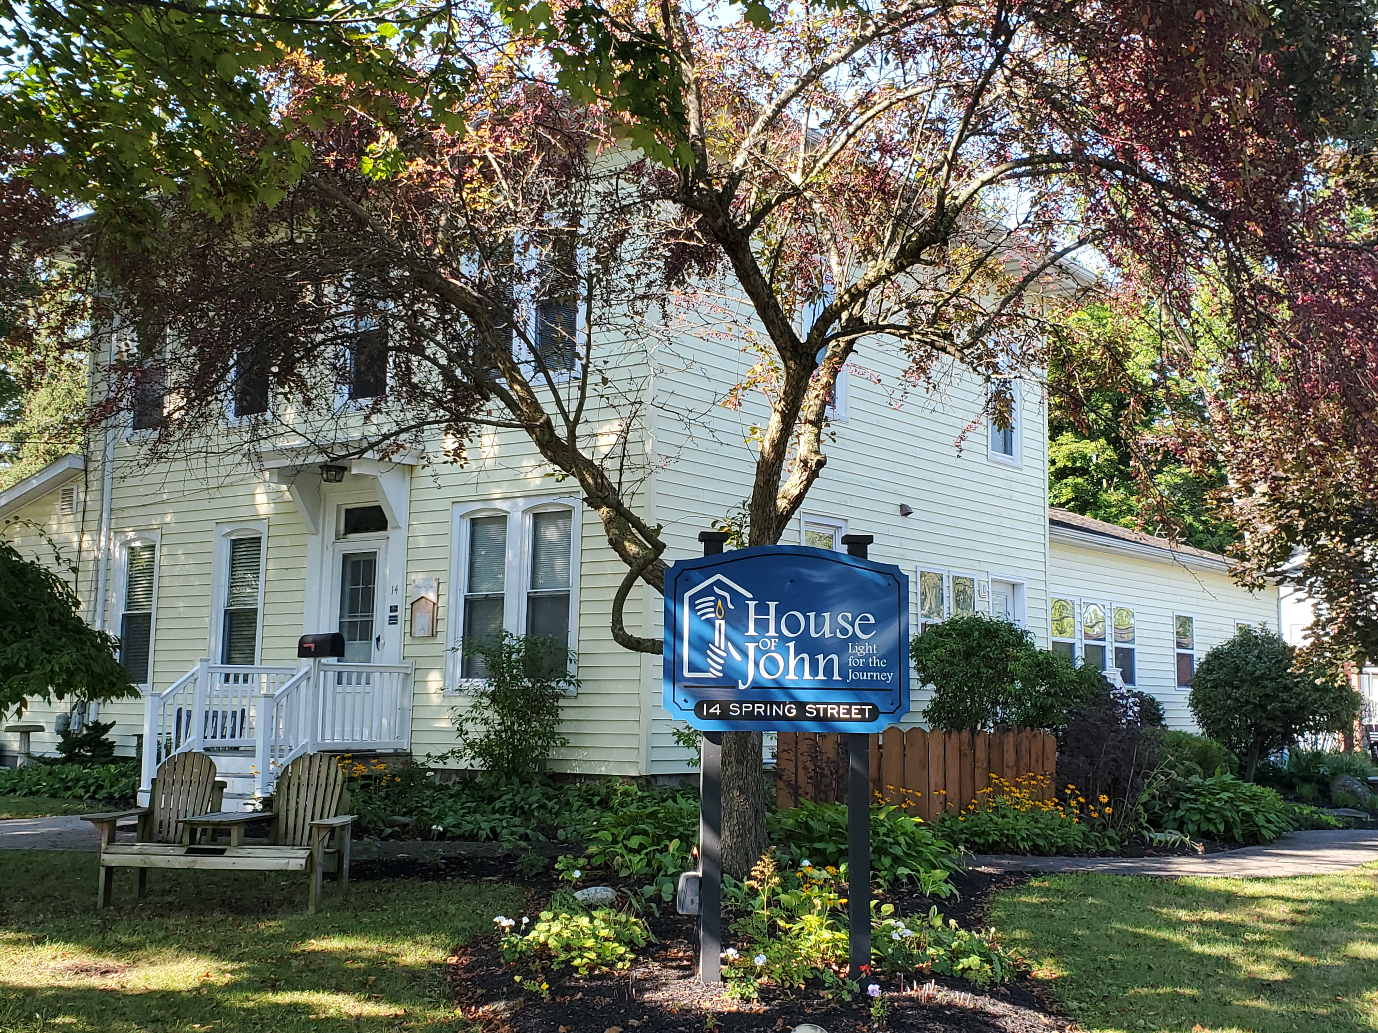

ANNUAL REPORT

2023
House of John
Email: house@houseofjohn.org  Website: houseofjohn.org | Tel: (315) 462-5646  14 Spring Street  Clifton Springs, NY 14432 | 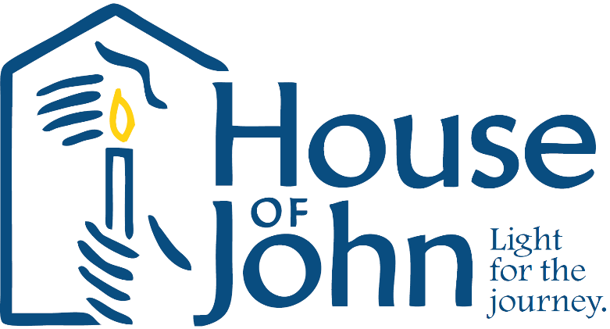

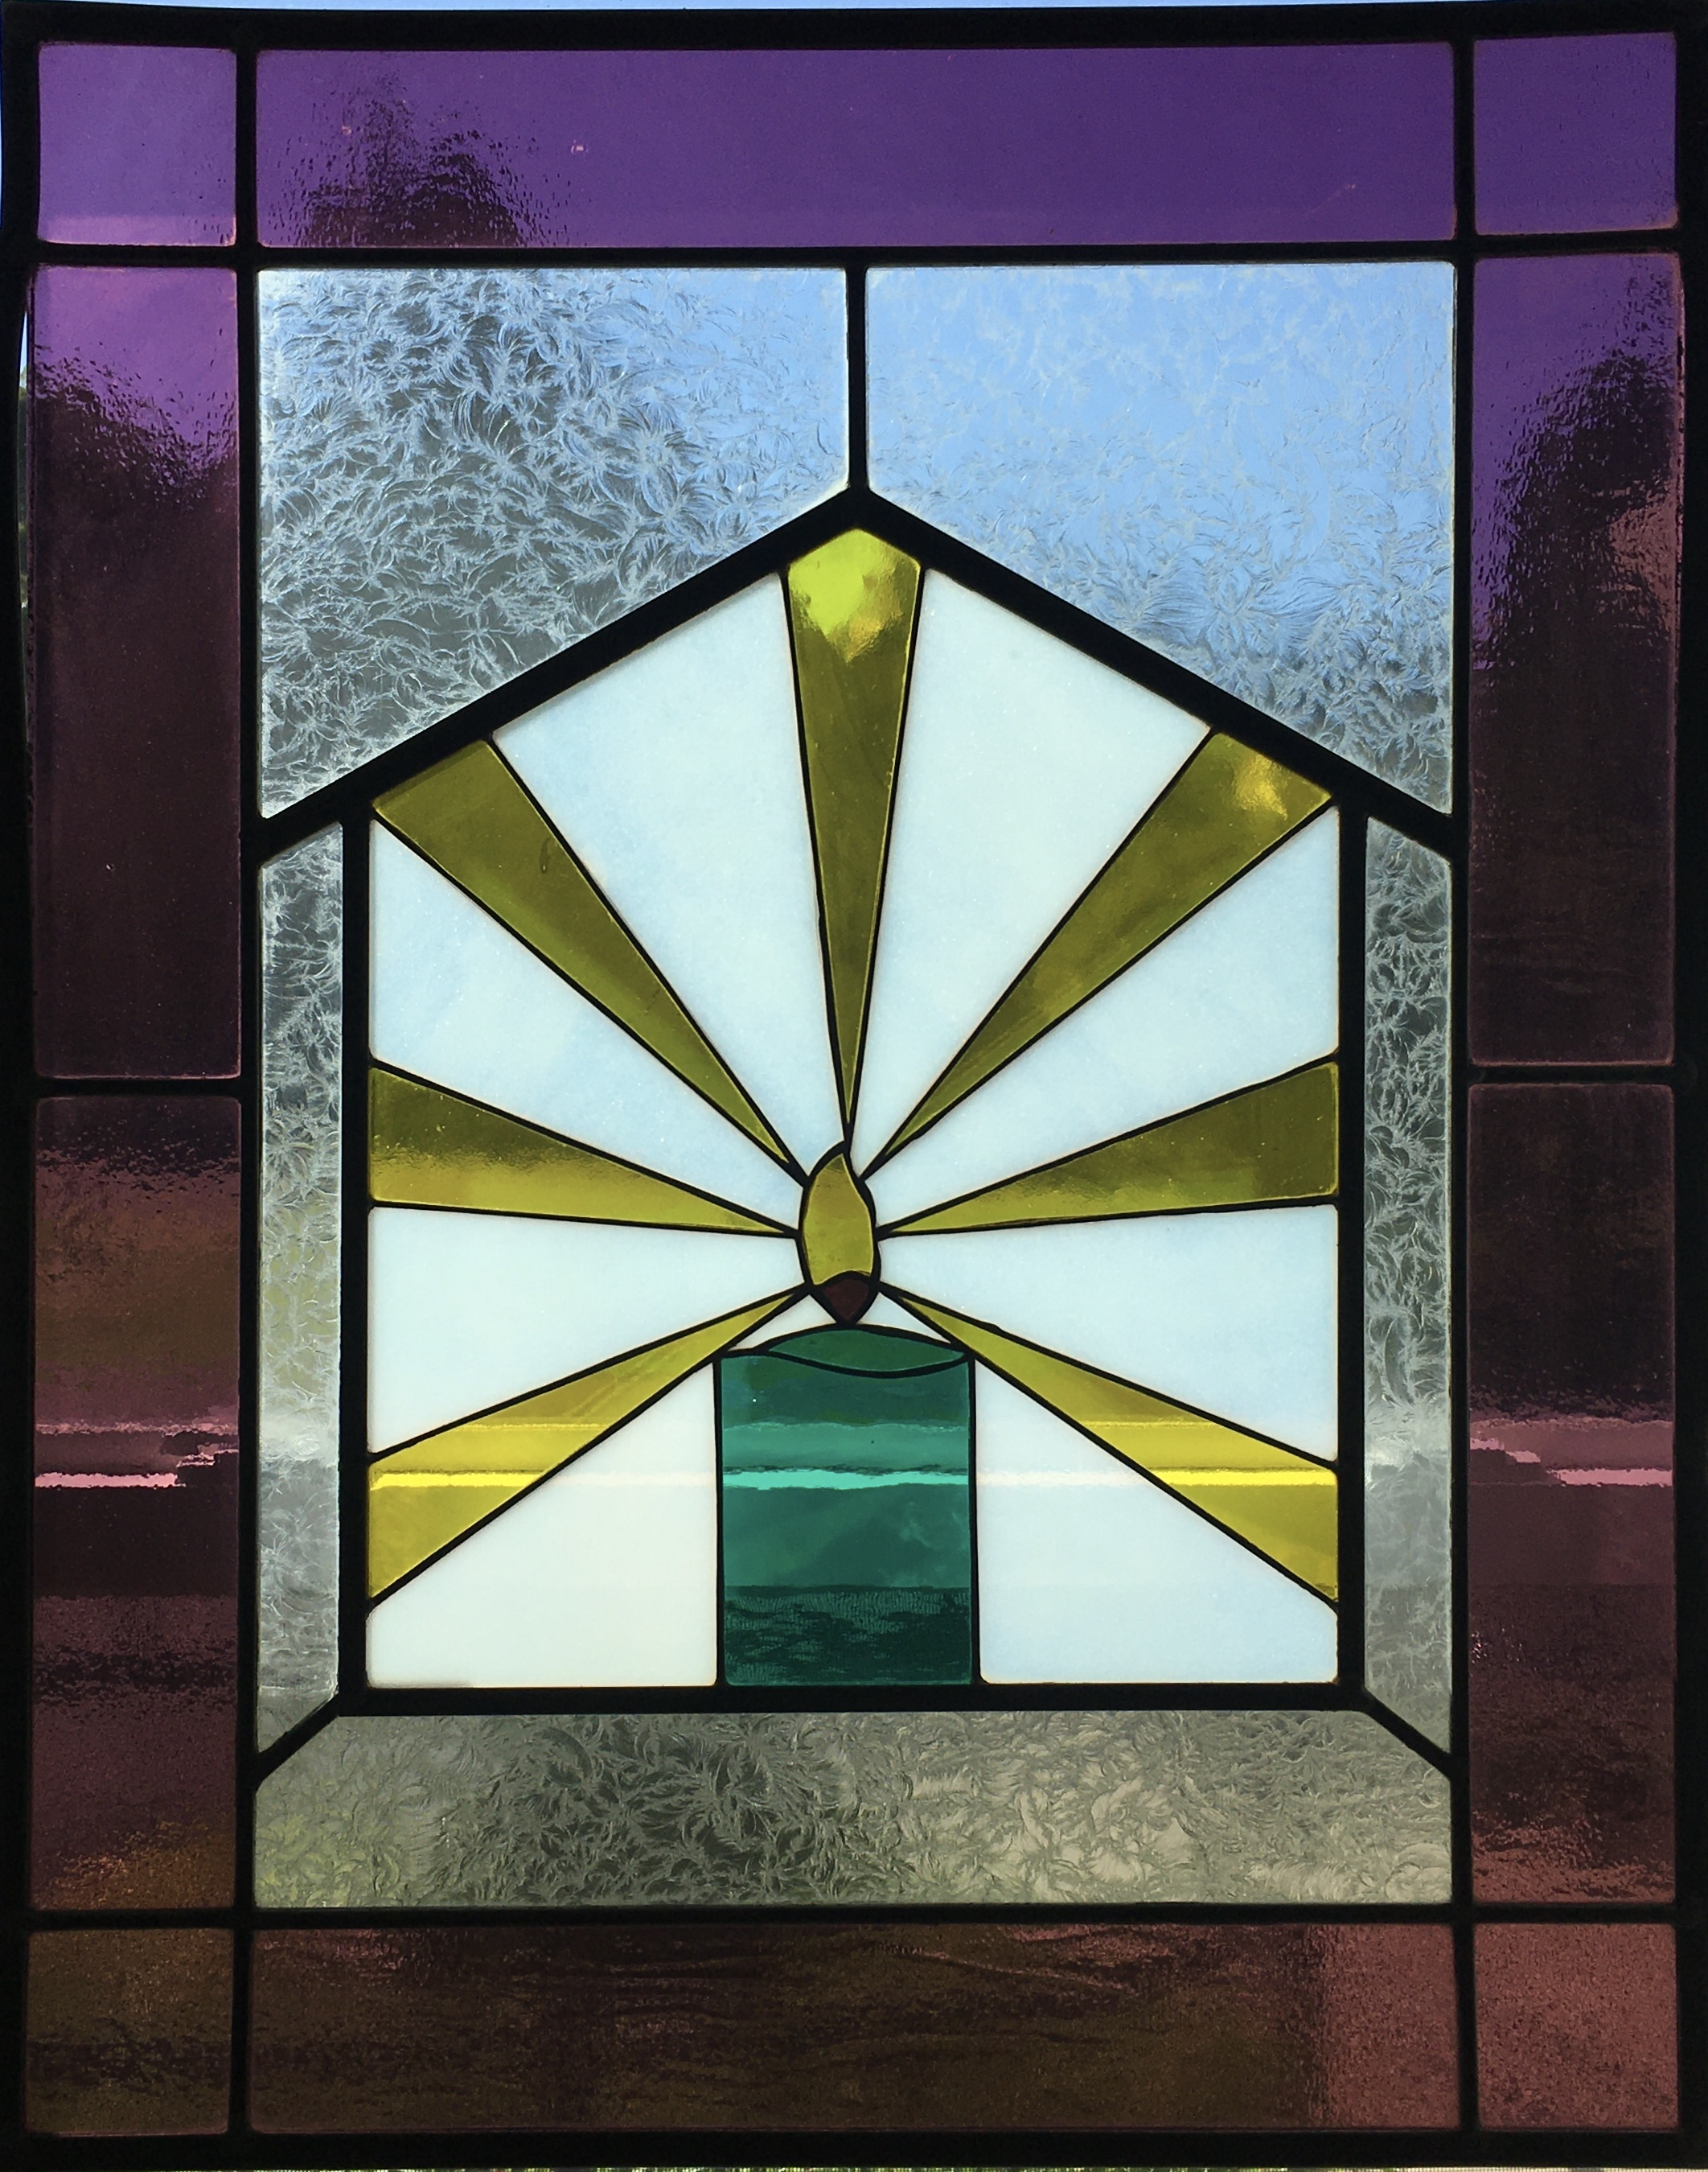
Our Mission
We open our house, our hearts and our hands to those who need physical care, emotional support and spiritual sustenance as they approach the end of their lives. We feel blessed to share the journey and we are privileged to be present with the family and loved ones during bereavement.
All services at House of John are free of charge. We depend completely on donations to keep the House in operation.
Comments from residents families
From a grateful family member
“My children and I could not have done it with all the comfort and dignity you gave him. We are eternally grateful to you all for helping us get through the process during this difficult time.”

Resident Information
The House of John assisted 16 residents, and their families, over 205 resident days in 2023. We provided 23 more days of care for the same number of residents as in 2022. All residents in 2023 lived in Ontario County before coming to the House of John.
We continue to care for one resident at a time due to the decreased number of active volunteers able to share their time with us.
153 referrals were received in 2023 from area hospitals, nursing homes, family members and UR Medicine Hospice. All referrals are reviewed, and contact made with potential residents and/or family members, by the HOJ Executive Director. The Director and Care Coordinator also visit potential residents face-to-face to discuss the House of John philosophy of care, answer questions, and to review the admission process and visitation policy. This introduction gives residents the opportunity to begin to build a rapport with the HOJ staff which can serve to ease anxiety on admission day.
Residents are chosen based on those with the most immediate need who have the fewest available resources for care.
The average length of stay in 2023 was 13 days with the shortest length of stay less than 24 hours and the longest was 77 days.
The average resident age was 79 years old. The age range of our residents during 2023 was 67 to 92 years of age.
The predominate medical diagnosis (88%) of our residents was a type of cancer. The other admitting diagnoses were end-stage kidney disease and end-stage Parkinson’s disease.

Our Staff and Volunteers
Resident care at House of John is provided by paid staff and a dedicated group of caring, compassionate, trained volunteers.
The paid staff of five remained consistent in 2023 with no new staff hired.
Three new volunteer training classes were held over the course of the year for 9 new volunteers, 4 of whom routinely provide resident care. Mandatory refresher in-service classes, called “Volunteer Connections”, are provided annually to inform staff and volunteers of any new policies and equipment as well as to review the HOJ confidentiality policy, Emergency Protocols and other household topics that the director would like addressed. Seven Volunteer Connections classes were held in July and August and all volunteers and staff attended.
A total of 37 volunteers provided 2,737 hours last year, enabling the House to remain open and continue providing end-of-life care for residents and families.
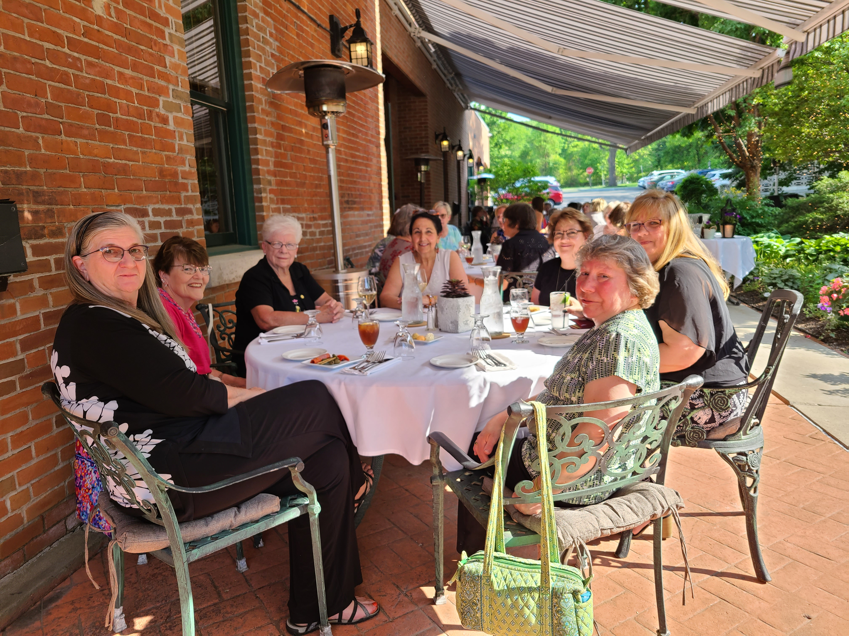
The beautiful garden at Warfield’s Restaurant was the site of the Volunteer Recognition dinner on May 31st. It was a
sunny, warm evening and the event was attended by 29 members of HOJ volunteers, Board of Directors members and staff.
Five volunteers were recognized for a total of 55 years of service, with one volunteer having given of her time and love to HOJ residents for 30 years!

A recurring “Coffee Hour” was initiated in 2023 to provide volunteers an opportunity to chat, share stories, ask questions, offer suggestions, and catch up on each other’s lives.
These gatherings are a wonderful opportunity for our volunteers to reconnect with each other!

Fundraising Events

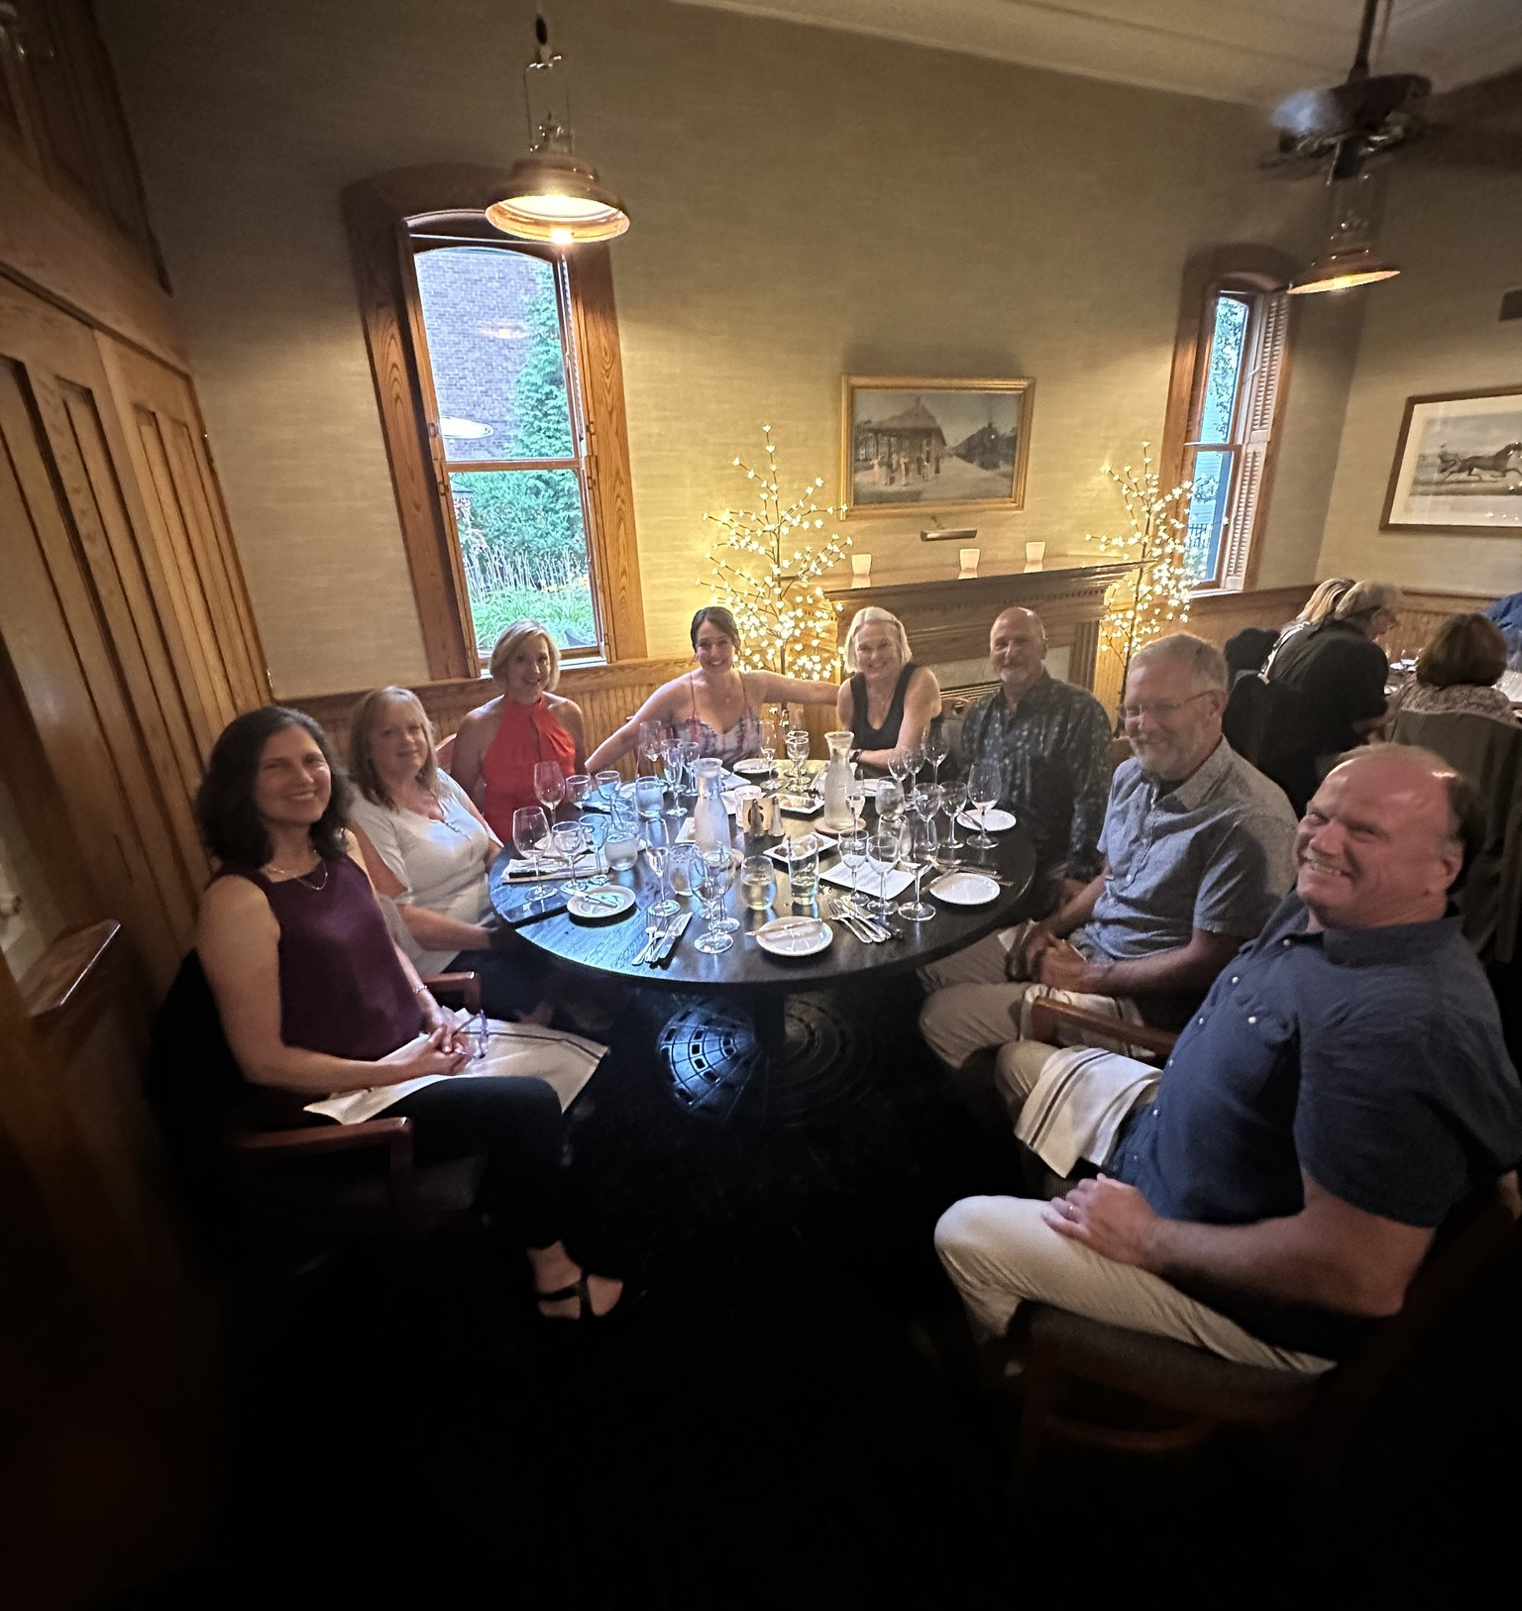
The first fundraiser of 2023 was the annual casino night event, held in conjunction with the Phelps Community Center. The “VooDoo Lounge” Casino Night was held on Sat., March 25th, at the PCC. There was a packed house at the “VooDoo Lounge” and it was our most successful casino night ever!

The Winemaker’s Dinner at Warfield’s Restaurant was held on July 29th and featured Italian wines and cuisine. This fundraiser is always a well-attended favorite of our supporters. Attendance increased from 2022 and HOJ was very fortunate to have raised nearly $6,800!

Thank you to all at Warfield’s Restaurant for the wonderful support to House of John!

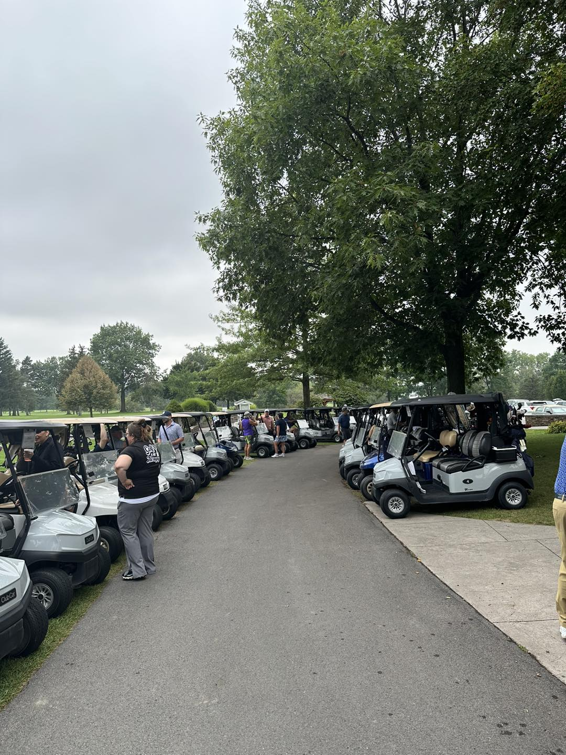
The House of John annual Golf Tournament at
Clifton Springs Country Club was held on August 21st.
It is historically the second most successful HOJ fundraiser and made over $22,000 last year.
.
Thank you to the Clifton Springs Country Club and all golfers, sponsors and donors that supported the golf tournament!

If you love golf and would like to support the important work that HOJ does, please consider golfing in or donating to the annual golf tournament in 2024! There’s room for additional golf teams and we’re always looking for more sponsors/donors!

The 2023 Annual Appeal raised over $88,000 in donations, which is a slight increase from the previous year. The letters went out in November, and focused on the impact that HOJ staff and volunteers make on family members, as well as on those residents who may not have family. Volunteers and staff become an extension of the family’s hands, allowing them to concentrate on being a family while we assume the responsibility of physical care. A recent family member commented that he was thankful for the opportunity to “go back to being the son and not the care giver” of his parent once his parent was admitted to HOJ.
The appeal goes through January 2024.

House Updates
A few minor updates to the House occurred in 2023. A utility sink was installed in the laundry/utility room and motion-activated outdoor lighting was installed at the entrances that did not have such lighting. One resident mattress, that had been intermittently malfunctioning, was replaced and a circulating air pump was purchased and installed for the mattress. The toilet in one resident bathroom was replaced with an extra tall toilet. Both upgrades were for improved resident comfort. Two new side chairs were also purchased for increased comfortable seating in the resident rooms. All purchases made for House updates were made possible from grant monies received.

Community Outreach
The HOJ director and care coordinator were again invited to do a presentation for the Excel nursing PCT interns at Clifton Springs Hospital in July. The presentation included general information about comfort care homes, the referral and admission to HOJ process, our focus on “Living” life until the end, and the role of volunteers.

The HOJ had an informational table with brochures and volunteer applications at the Phelps Sauerkraut Festival last summer. Thank you to Pete Cheney and Smokin Tails Distillery for providing a shaded location.

HOJ provided a clinical site for both Roberts Wesleyan College and St. John Fisher University nursing students during the fall semester. In total, eleven students completed 176 “End-of-Life Care” hours in 2023. As a result of St. John Fisher students becoming familiar with our organization by completing clinical hours and a service project here, House of John was placed in the Student Choice Opportunity booklet. The booklet is a resource for any SJFU student participating in the university’s Service Scholar Program who is looking to complete a service project.

30th Anniversary
The House of John celebrated our 30th Anniversary on September 14th
of 2023 and commemorated the milestone with a community event
featuring Dr. Christopher Kerr, a Hospice/Palliative Care physician and
CEO and Chief Medical Officer at Hospice Buffalo. There was also a
window display announcing our 30th anniversary at the Clifton Springs
Chamber of Commerce during the entire month of September.

The House opened for its first resident on September 14th in 1993. Over
the past 30 years, the dedicated staff and volunteers have touched the
lives of 800 residents and countless families and friends.
to the dying process.
Recruiting new volunteers remains the priority for 2024!
House staff will concentrate on reaching potential volunteers in the Geneva area this year and have contacted several churches in Geneva and the surrounding area asking to have the HOJ volunteer recruitment flyer shared to their parishioners. The Executive Director and Care Coordinator are always happy to speak to community groups to share the history of the HOJ, discuss end-of-life care and explain the important role that volunteers play.

The HOJ listing on the Finger Lakes Community College “FLCC Volunteers” website, a website to help link would-be volunteers with local agencies in need of volunteers, has been updated.
Staff, volunteers, and members of the board of directors are encouraged to use social media to reach out to their contacts as well as to share the mission of the HOJ with family, friends, and co-workers.
Please “Like” the HOJ Facebook page: https://www.facebook.com/people/House-of-John/100064542258136/

Volunteers Needed
If you are a caring, compassionate individual and are interested in giving back to your community, please consider joining the House of John family. Staff and volunteers provide physical care and emotional support to residents and their families at end-of-life. Volunteering here at the House can be a rich experience, one that binds our House of John family together, enriches the greater community and makes a difference every day in the lives of our residents and their loved ones.

All training and orientation are provided for volunteer caregivers free of charge. Initially, prospective volunteers shadow with a seasoned volunteer to become acquainted with the House. Following volunteer training, new volunteers are always paired with an experienced caregiver until they feel confident being on their own. The HOJ volunteer application may be found by scanning the QR code or at:
https://www.houseofjohn.org/uploads/1/1/8/8/118835624/hoj_volunteer_app.pdf

We invite you to check our website, HouseofJohn.org, for pictures of the inside of our wonderful home and to view a short video which can be found on the “About Us” page below “Our Story”. https://www.houseofjohn.org/about.html

