ANNUAL REPORT

2021
House of John
Email: house@houseofjohn.org  Website: houseofjohn.org | Tel: (315) 462-5646  14 Spring Street  Clifton Springs, NY 14432 | 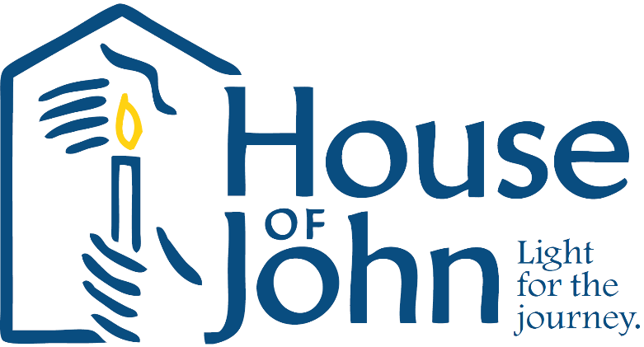

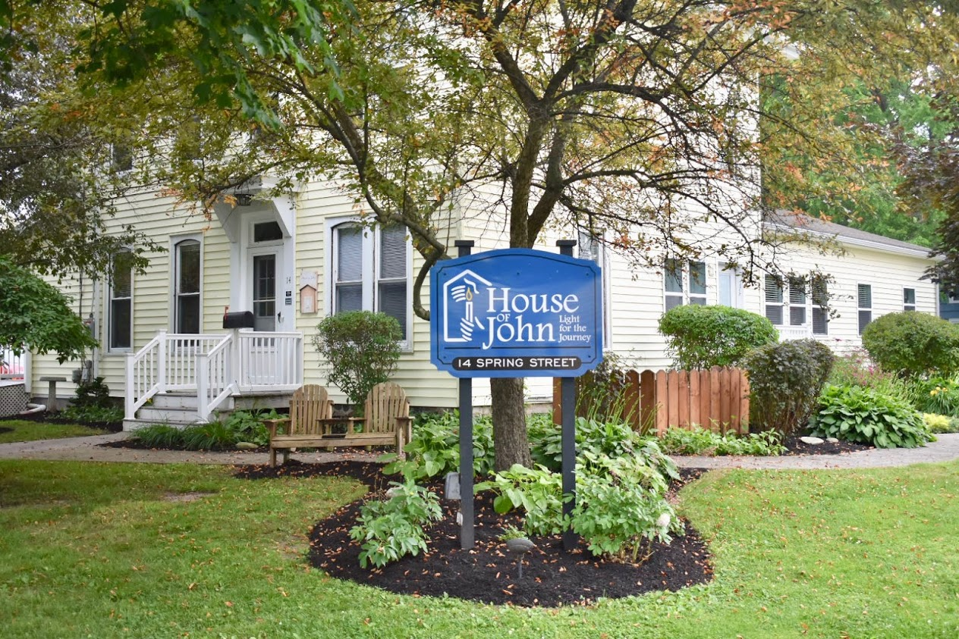

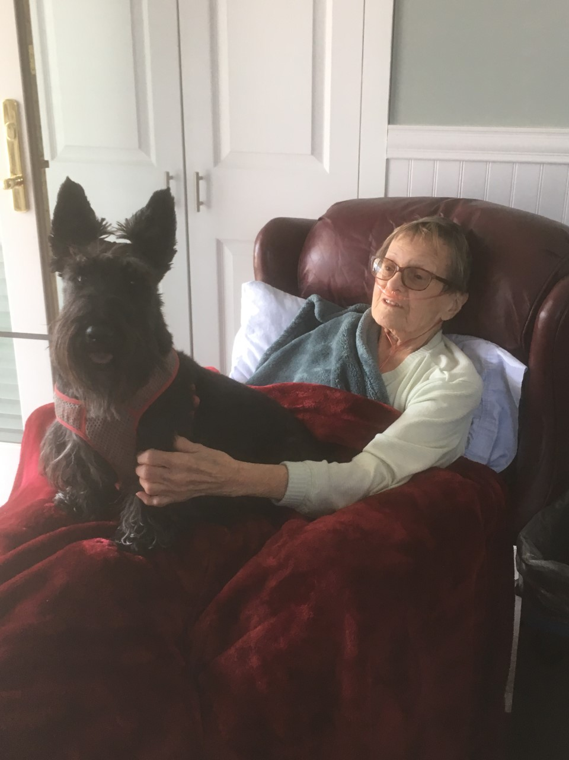
Our Mission
We open our house, our hearts and our hands to those who need physical care, emotional support and spiritual sustenance as they approach the end of their lives. We feel blessed to share the journey and we are privileged to be present with the family and loved ones during bereavement.
All services at House of John are free of charge. We depend completely on donations to keep the House in operation.
Comments from a resident’s family “My family and I have never been more impressed and appreciative of any organization. You provide a tremendous service to residents, families and the community. We hope you can use this donation to ‘pay it forward’, providing other families with the care and comfort that we were so fortunate to experience. Thank You”

Resident Information
In the midst of the COVID-19 pandemic, the House of John was able to remain open and provide care for 174 resident days in 2021, helping 21 residents and their families make the most of their remaining days in the comfort, care and safety of our home.
193 referrals were received in 2021 from area hospitals, nursing homes, family members and UR Home Care (formerly Ontario Yates Hospice) which is up from 167 referrals in 2019 and 168 referrals in 2020. All referrals are reviewed and contact made with potential residents, as appropriate, by the HOJ Executive Director. Residents are chosen based on those with the most immediate need who have the fewest available resources for care.
The average length of stay was 9 days with the shortest length of stay being less than 24 hours and the longest of 56 days.
The average resident age was 80 years old. The age range of our residents during 2021 was 52 to 101 years of age.
The predominate medical diagnosis (76%) of our residents was some type of cancer. Other admitting diagnoses were lung abscess, pneumonia, end stage dementia, and COPD.
The majority of our residents (16) resided in Ontario County before making the House of John their home. We also shared our home with three residents from Monroe County and one each from Wayne and Yates Counties.

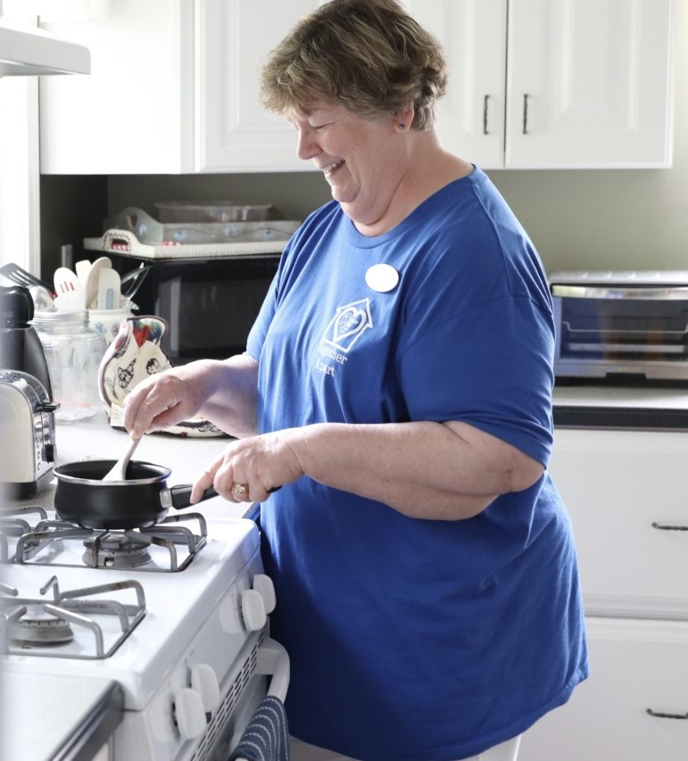
Our Staff and Volunteers
Resident care at House of John is provided by both paid staff and a small group of caring, selfless volunteers.
The COVID-19 pandemic has affected the HOJ in numerous ways and has presented staffing challenges with both paid staff and the volunteer pool. Three staff members left the employ of HOJ in 2021, one night aide, one on-call nurse, and the Care Coordinator. All three positions have been filled though overnight staffing is still problematic at times and there are now just 2 on-call nurses. The search for per diem overnight staff and an additional on-call nurse is ongoing.

The number of active volunteers has decreased by more than 50% since January of 2020, though eight volunteers that had “paused” being here since the start of the pandemic did return. Two new volunteers were trained during 2021 and continue to offer their time regularly.
We believe that most of our volunteers that are not currently able to be here have stepped away for personal or health reasons or because they do not feel comfortable providing care during the pandemic. There are two previous volunteers, that we are aware of, that chose not to get the COVID vaccine and are therefore not eligible to continue to volunteer, as per our policy.
We currently have a core group of 18-20 volunteers that often give eight to sixteen hours a week of their time. Volunteers provided a total of 1,720 hours last year, enabling the House to remain open and continue providing care to those at end-of-life.
The House has not gathered to recognize our wonderful volunteers since 2019, cancelling the Volunteer Recognition dinners in both 2020 and 2021.
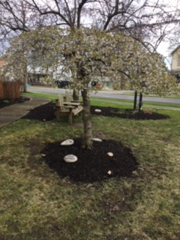
Recruiting new volunteers is a priority for 2022!
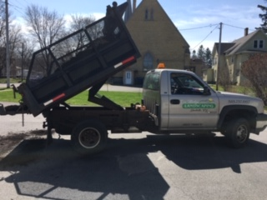
Fundraising Events
The COVID-19 pandemic has affected some of our fundraising methods. To continue to follow CDC guidelines, “Casino Night”, one of only four annual fundraisers and usually held in late winter, was cancelled for the second year in a row. The Winemakers Dinner was held during the warmer months, with fewer attendees and with part of the event held outdoors.
The HOJ Fundraising Committee meets regularly to plan fundraising events and in late 2021 a Fundraiser and Events Coordinator was hired to assist with the efforts.
A new and tasty fundraiser was added in early 2021 to help beat the winter blues.
A “Cupcakes and Cider Pairing” event was held in January and featured a take-home box with 4 homemade gourmet cupcakes from Cake Baby and
1 bottle of cranberry cider from Star Cider. Orders were placed ahead of time and picked up on January 30th. This new fundraiser completely sold out, well before the date of the event!
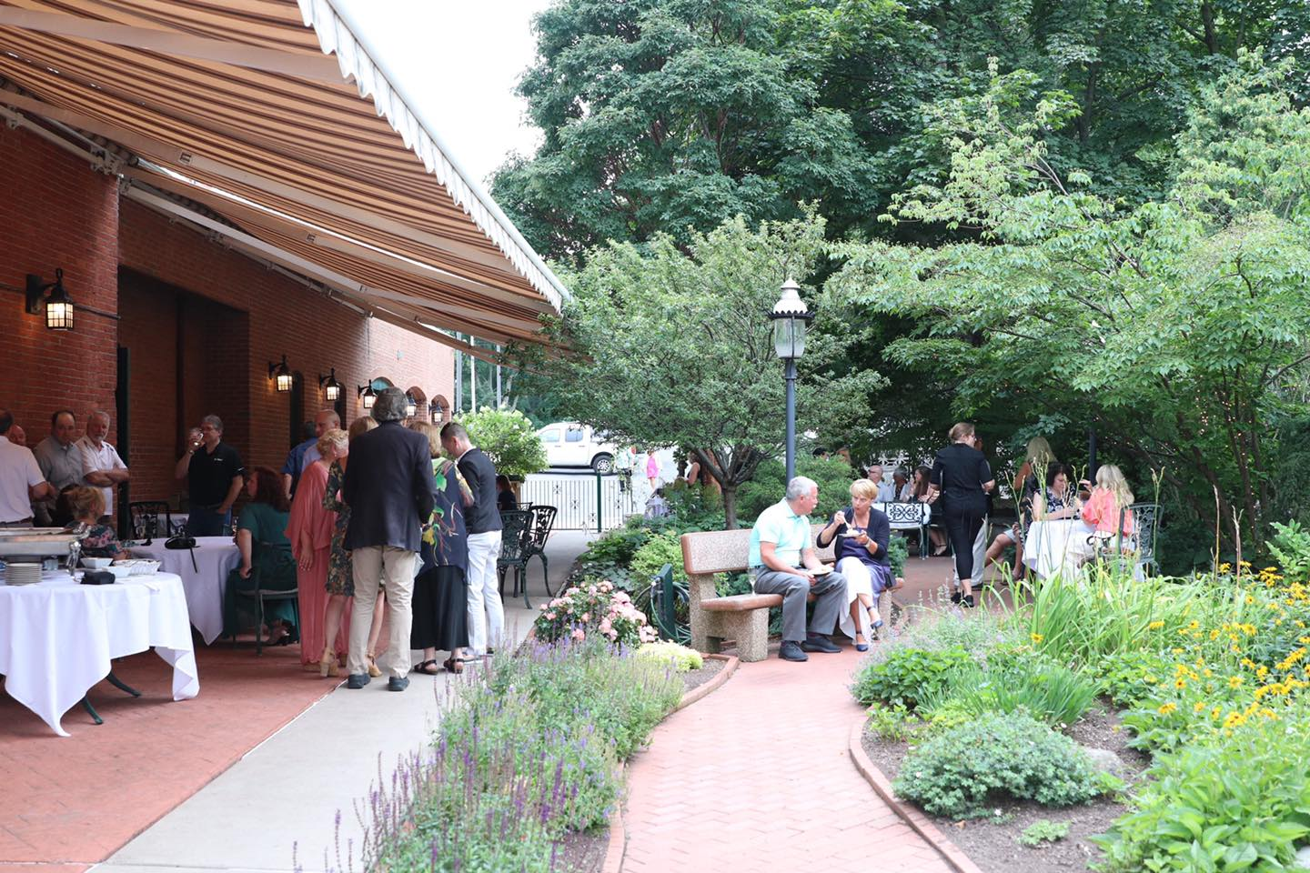

“Wine Under the Stars”

The annual winemaker's dinner returned in 2021 and was held at Warfield's on Saturday July 24^{th.} Hors d’oeuvres were served outdoors in the garden. Dinner featured a mouth-watering meal prepared by Warfield’s Executive Chef, Phil Yautzy. A sommelier from Dr. Konstantin Frank Winery guided guests through the delicious four course meal explaining the food and wine pairing choices. It was a beautiful summer evening!
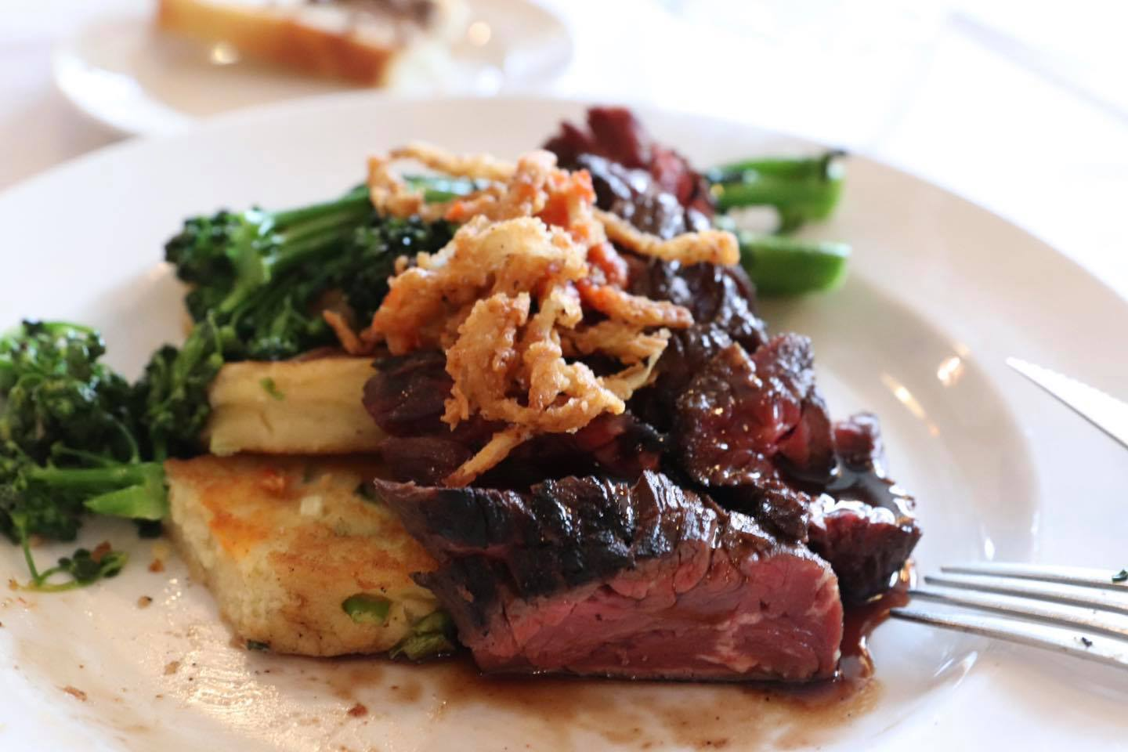

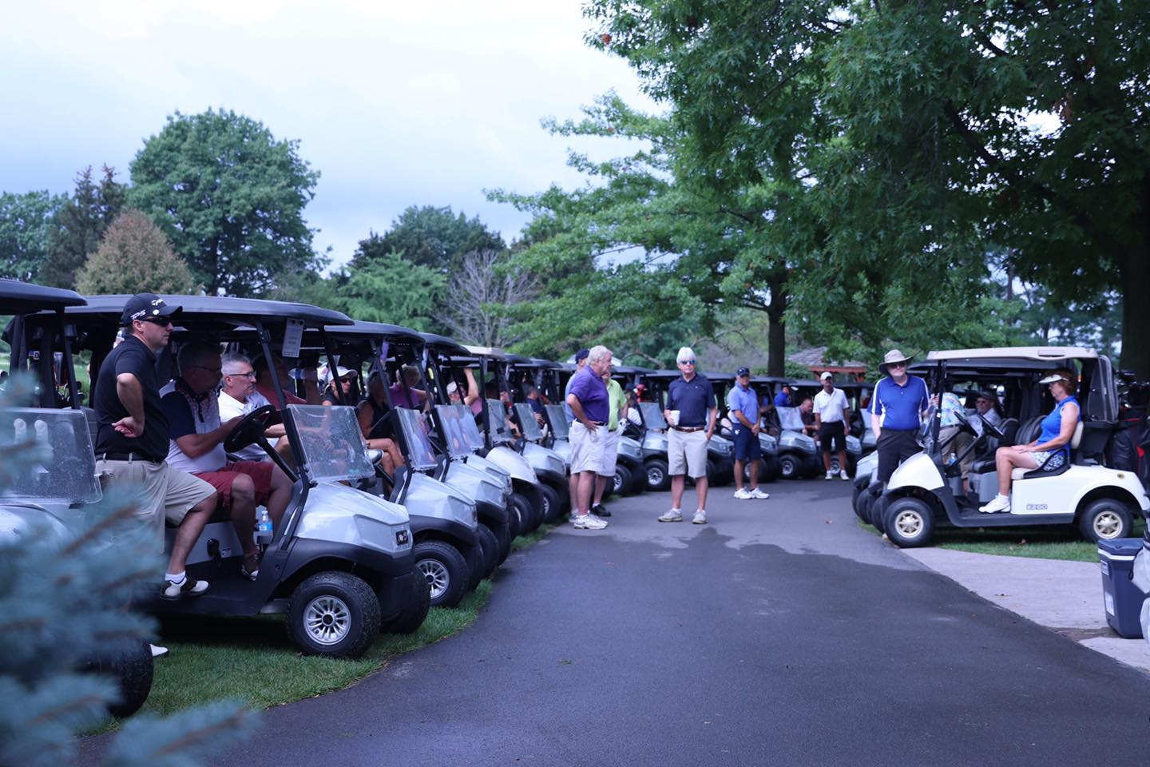

The 25th annual golf tournament held at the
Clifton Springs Country Club was a huge success!
Net proceeds from the event totaled more than
$22,000 which directly supports the services we
provide for the families who receive care here at
House of John.

Achievements
There were numerous improvements made at HOJ over the past few years, which would not have been possible without donations and grant monies as well as many hours of volunteered time and talents. Both resident rooms have been freshly painted and had new flooring, ceiling fans, storage closets, sinks, faucets and vanities installed. The updates made the resident rooms look fresh and inviting. The front hallway, stairwell and upstairs hallway have also had work done with new wallpaper and carpeting and the guest bathroom was “refreshed”.
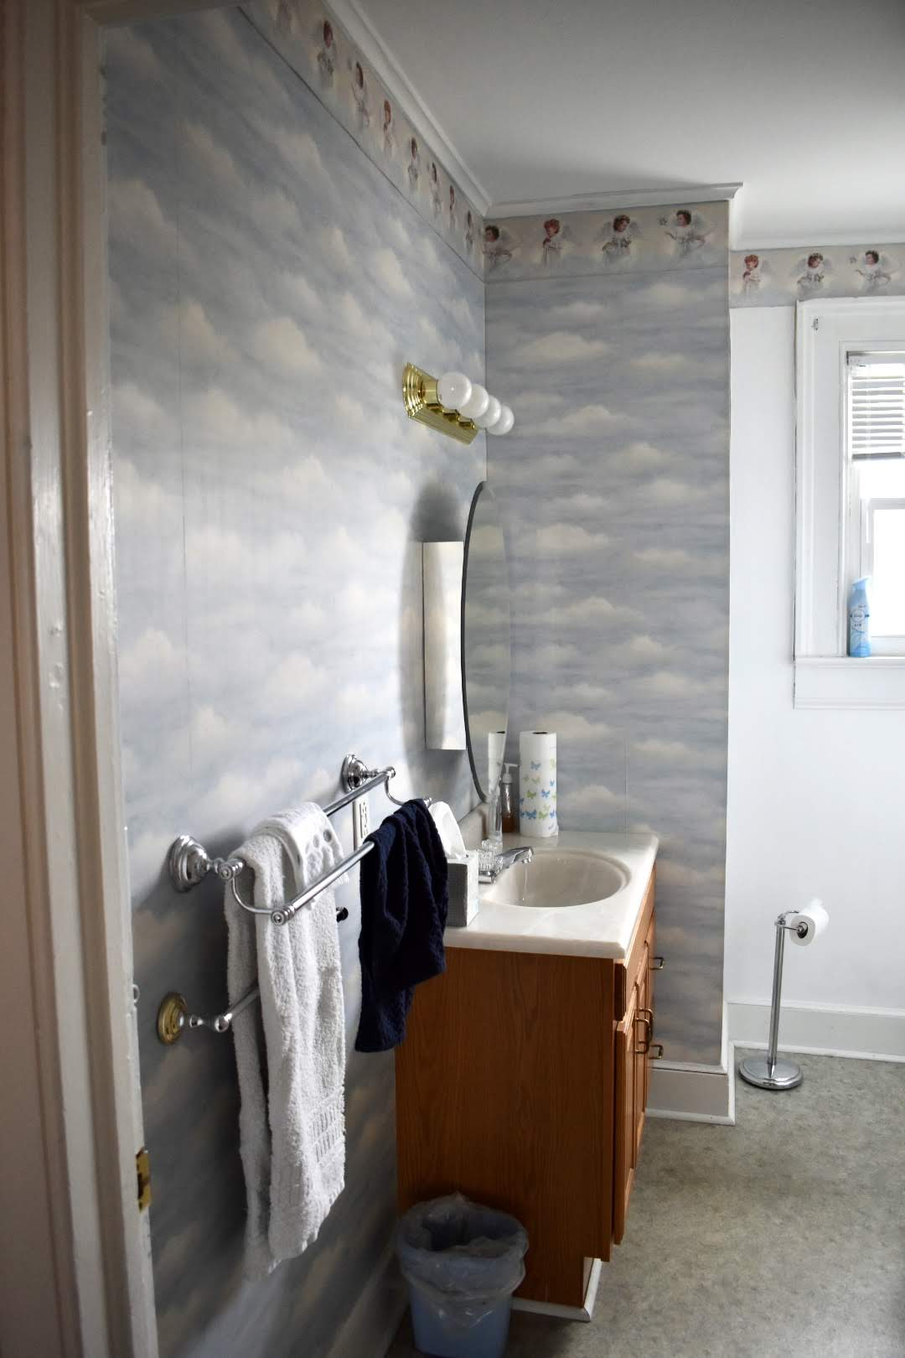
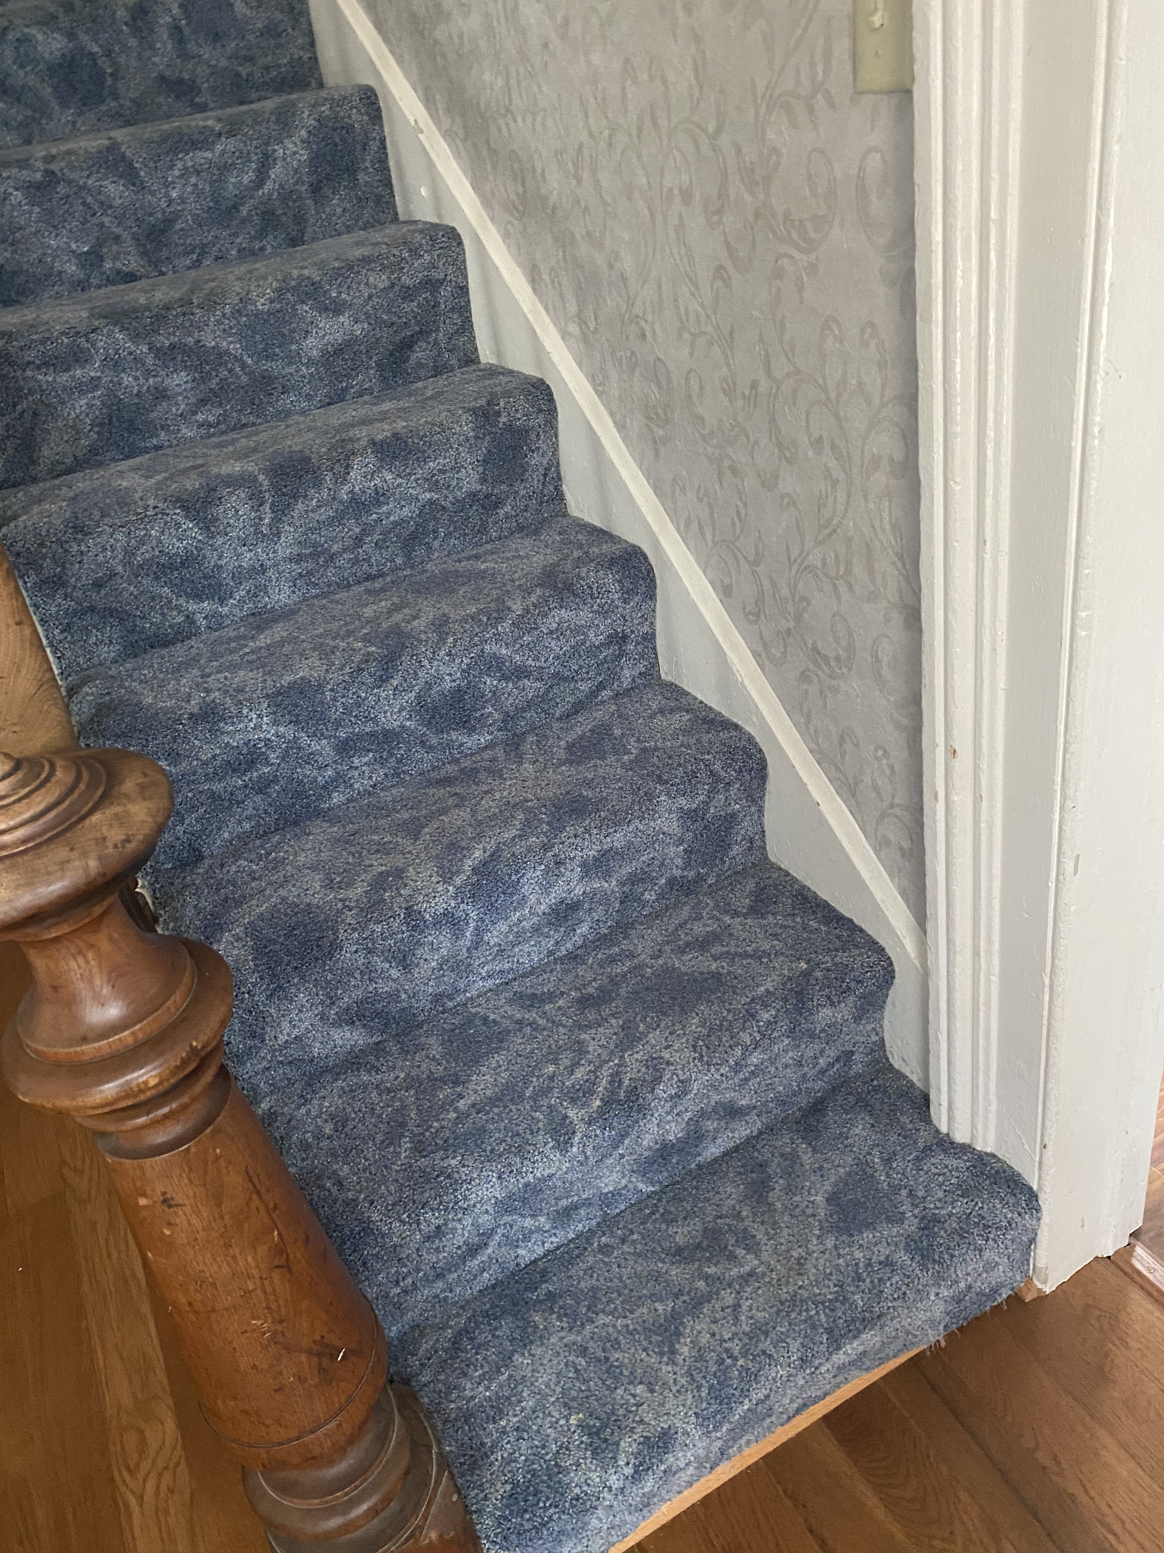
Old blue carpeting on the stairs and in the hallway and guest bedrooms was replaced with new pad and durable carpet

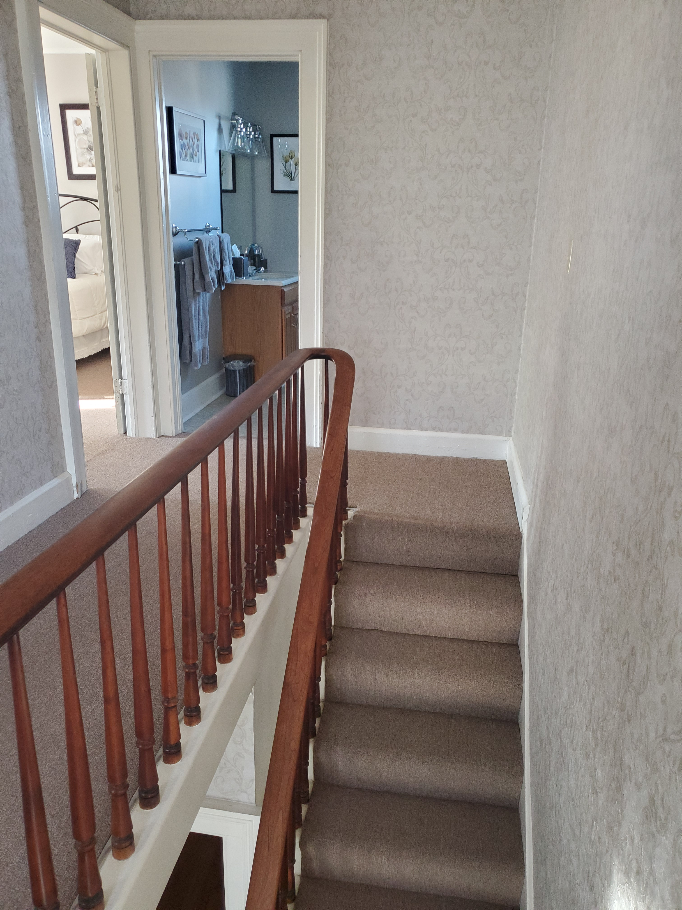
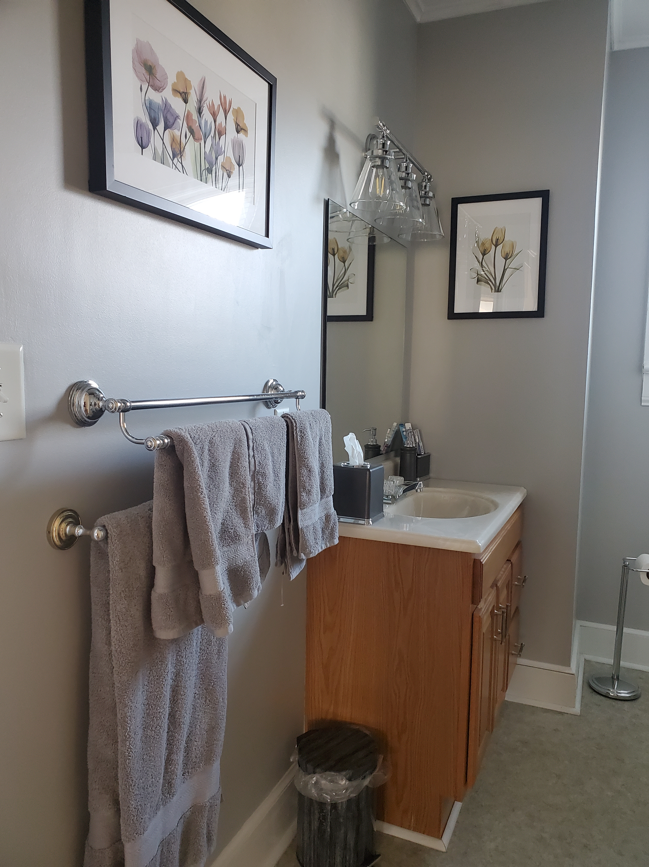
Before and after pictures of the
upstairs guest bathroom
renovation

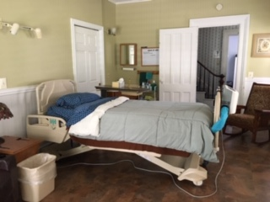
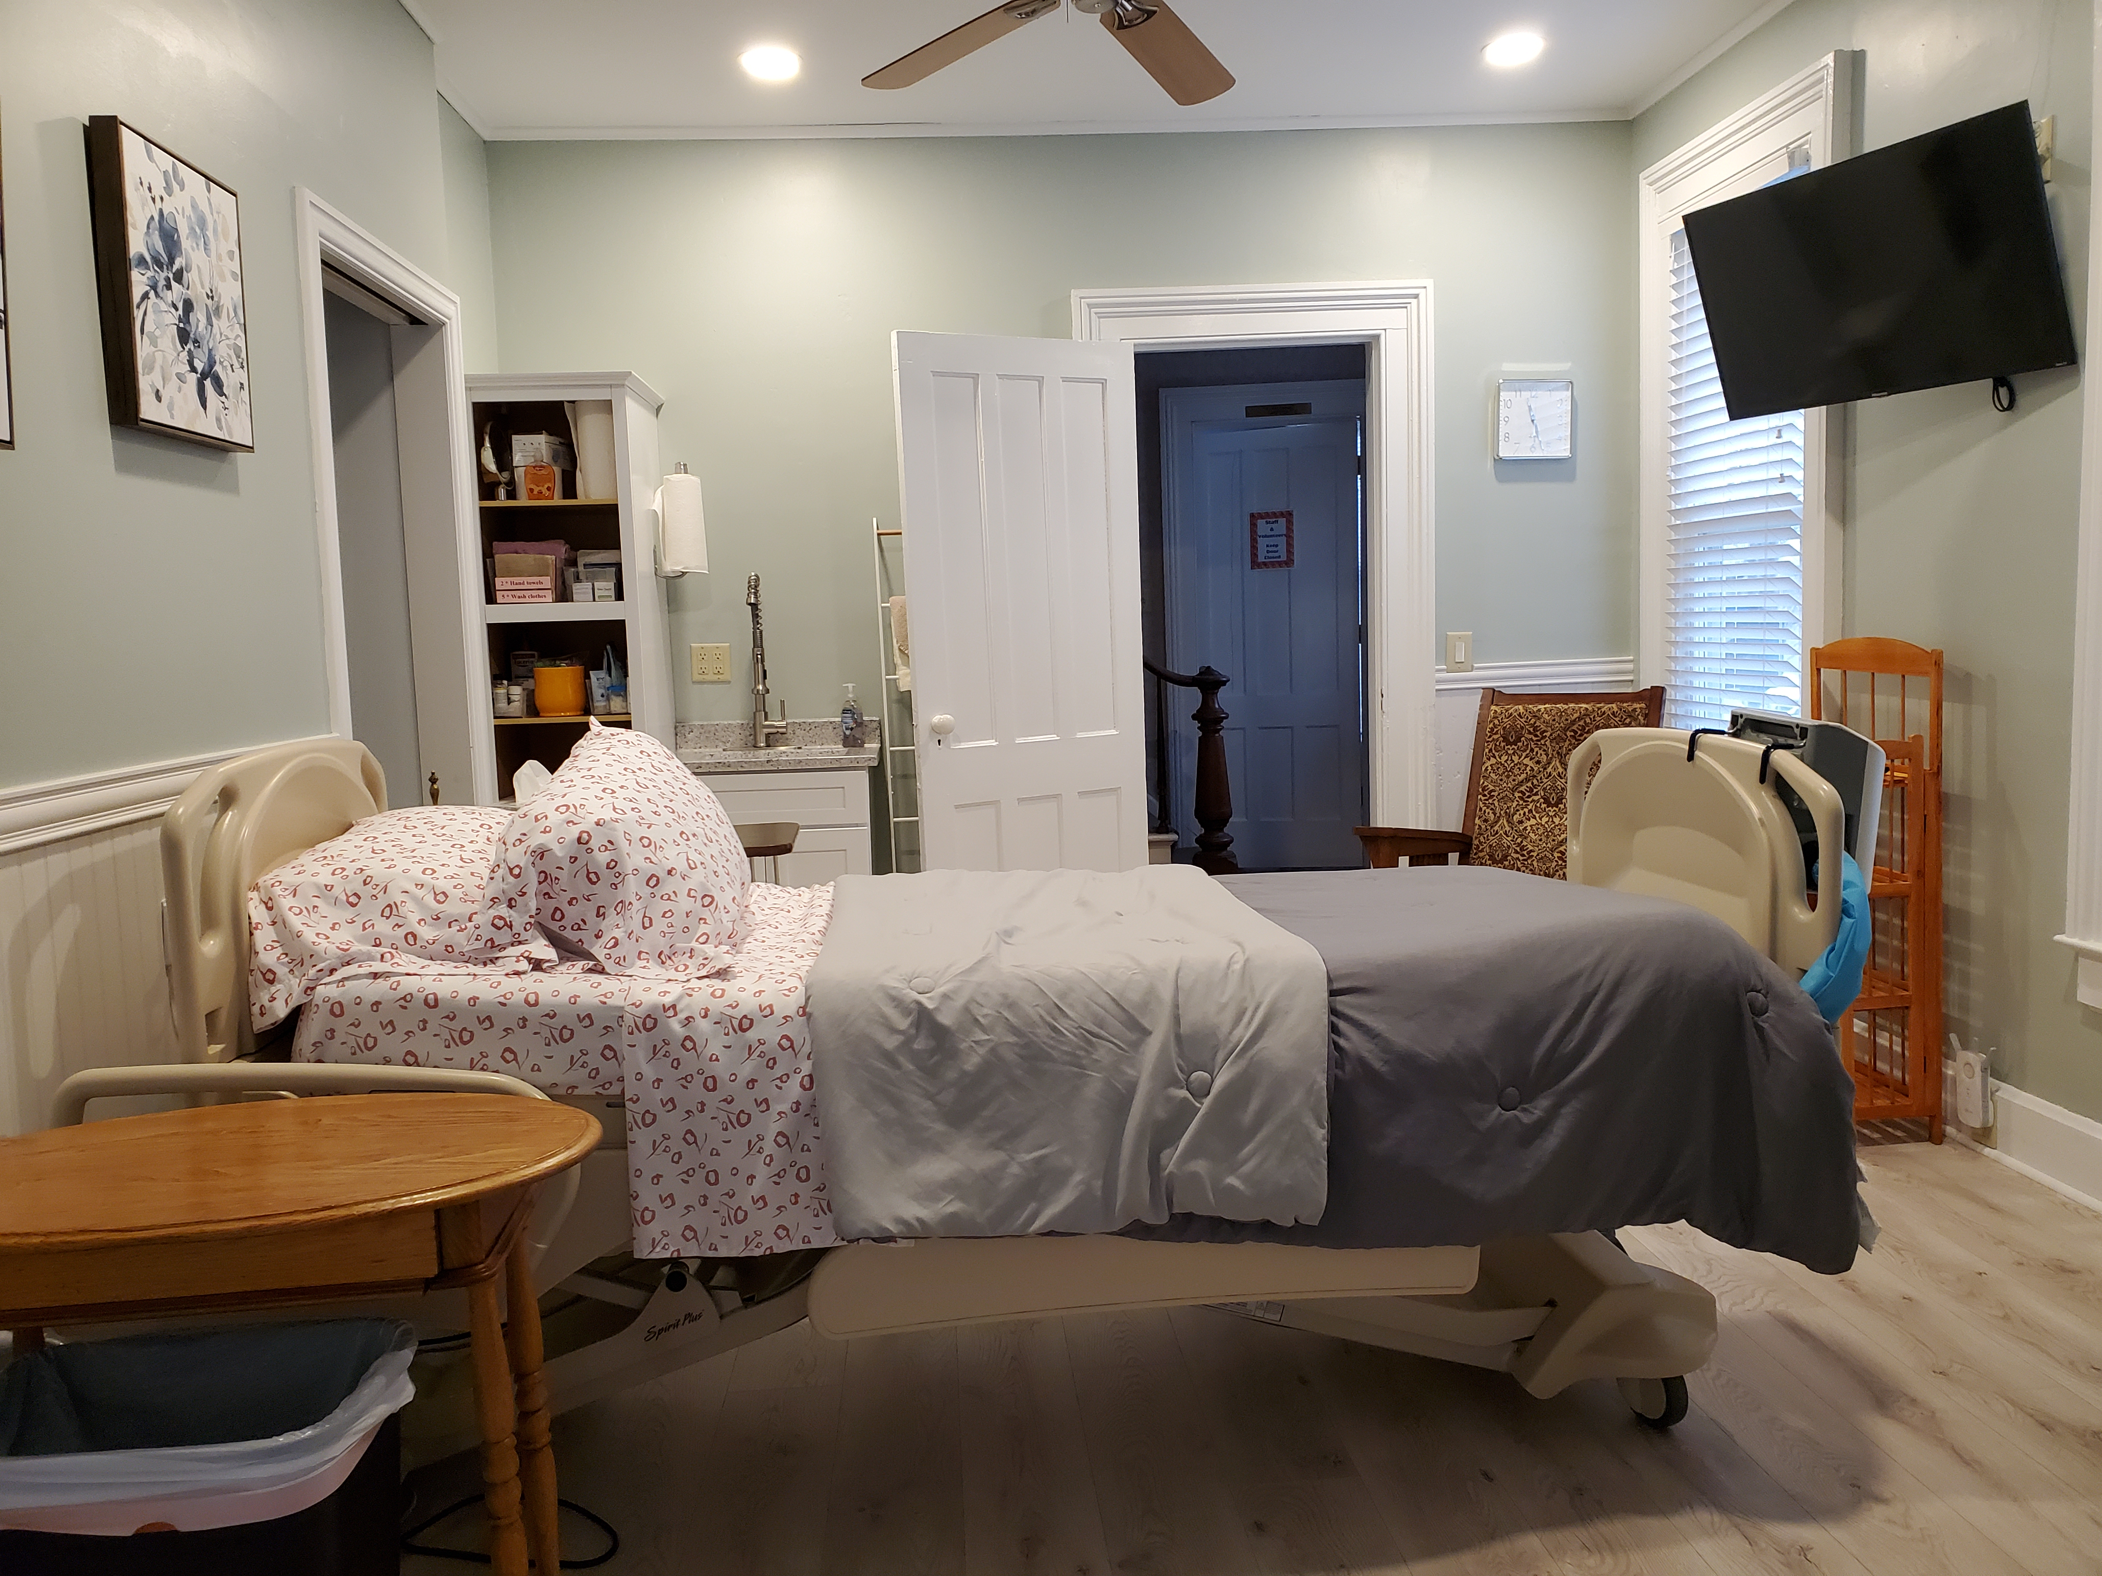
Resident room before renovations

…and after
Community Support
The local community support for House of John is remarkable. Throughout the year, the House receives not only monetary donations but also gifts of household items, personal care items, durable medical supplies and equipment (dressing supplies, walkers, crutches, shower chairs, commodes) food, and even appliances, as well as landscaping, construction and “handy man” services. The 2021 House of John Annual Appeal campaign yielded $80,884 in donations. These generous donations make it possible for the House to fulfill our mission.
The House also contributes to the community by giving back. The numerous pieces of durable medical equipment that are donated by residents, families and the local community are made available to others through our “loan closet”. The House gets frequent phone calls from individuals in need of equipment to care for a home-bound family member, neighbor or friend. Callers express both relief and gratitude at the ability to borrow the needed equipment and at no cost.
Challenges Moving Forward
Significant decrease in volunteers pool
As previously noted, our volunteer pool has decreased by more than 50% since the beginning of the pandemic, therefore recruiting new volunteers is our highest priority for 2022.
Several steps have already been taken to address this urgent need. Approximately 70% of U.S. adults use social media to connect and engage with others. Current volunteers and members of the board of directors have been asked to use social media to reach out to their contacts and “share” the HOJ volunteer recruitment information which is posted on our Facebook page.
Printed “Volunteers Needed” flyers have been posted in several local businesses and the flyer was posted on electronic bulletin boards at G. W. Lisk Co. in December and February. The flyer has also been posted several times in the Clifton Springs Chamber of Commerce newsletter over the past few months and a “Discover the House of John” paragraph was included in the Clifton Springs Quarterly newsletter and distributed with the February water bills. The Midlakes Schools District Clerk recently printed the flyers and distributed them in several common areas for staff review. The FLCC Development Office and a few local churches were also emailed the flyer asking for it to be shared with staff/parishioners. We have not yet received a response to these requests. Various efforts to recruit new volunteers will continue throughout the year.

Please Share:
Volunteers Needed
If you find yourself with a few extra hours of time each month and are interested in giving back to your community, please consider joining The House of John family. Staff and volunteers provide physical care, emotional support and spiritual sustenance as residents approach end of life. Volunteering here at the House can be a rich experience, one that binds our House of John family together, enriches the greater community and makes a difference every day in the lives of our residents and their loved ones.
Training and orientation are provided for all volunteer caregivers.
Initially, prospective volunteers shadow with a seasoned volunteer to become acquainted with the House. Following volunteer training, new volunteers are always paired with an experienced caregiver.

We invite you to check our website for pictures of the inside of our
wonderful home and to view a short video on the “About Us” page.
http://www.houseofjohn.org/

